1.Write a Java program to get the character at the given index within the String.

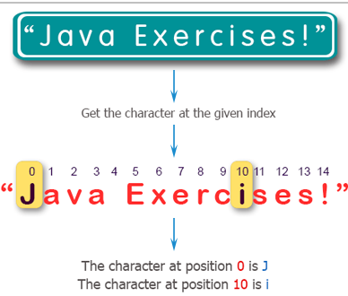

2.Write a Java program to get the character (Unicode code point) at the given index within the String.

3.Write a Java program to get the character (Unicode code point) before the specified index within the String.

4.Write a Java program to compare two strings lexicographically. Two strings are lexicographically equal if they are the same length and contain the same characters in the same positions.

5.Write a Java program to compare two strings lexicographically, ignoring case differences.

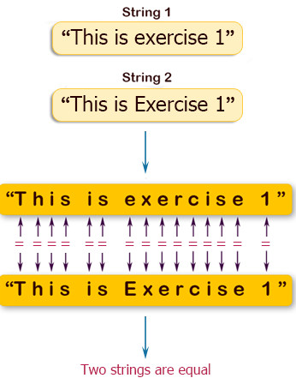

6.Write a Java program to concatenate a given string to the end of another string..

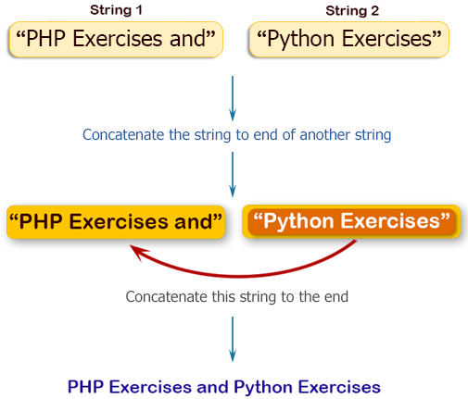

7.Write a Java program to compare a given string to the specified string buffer..

8.Write a Java program to create a new String object with the contents of a character array.

9. Write a Java program to get the contents of a given string as a byte array.

10.Write a Java program to get the contents of a given string as a character array.

11.Write a Java program to create a unique identifier of a given string.